How to Post Wires
First Step: Downloading File from EFS Site and Saving it
Log in EFS Site
Go to: Select Program > Report/ Exports > Issued Money Code Report

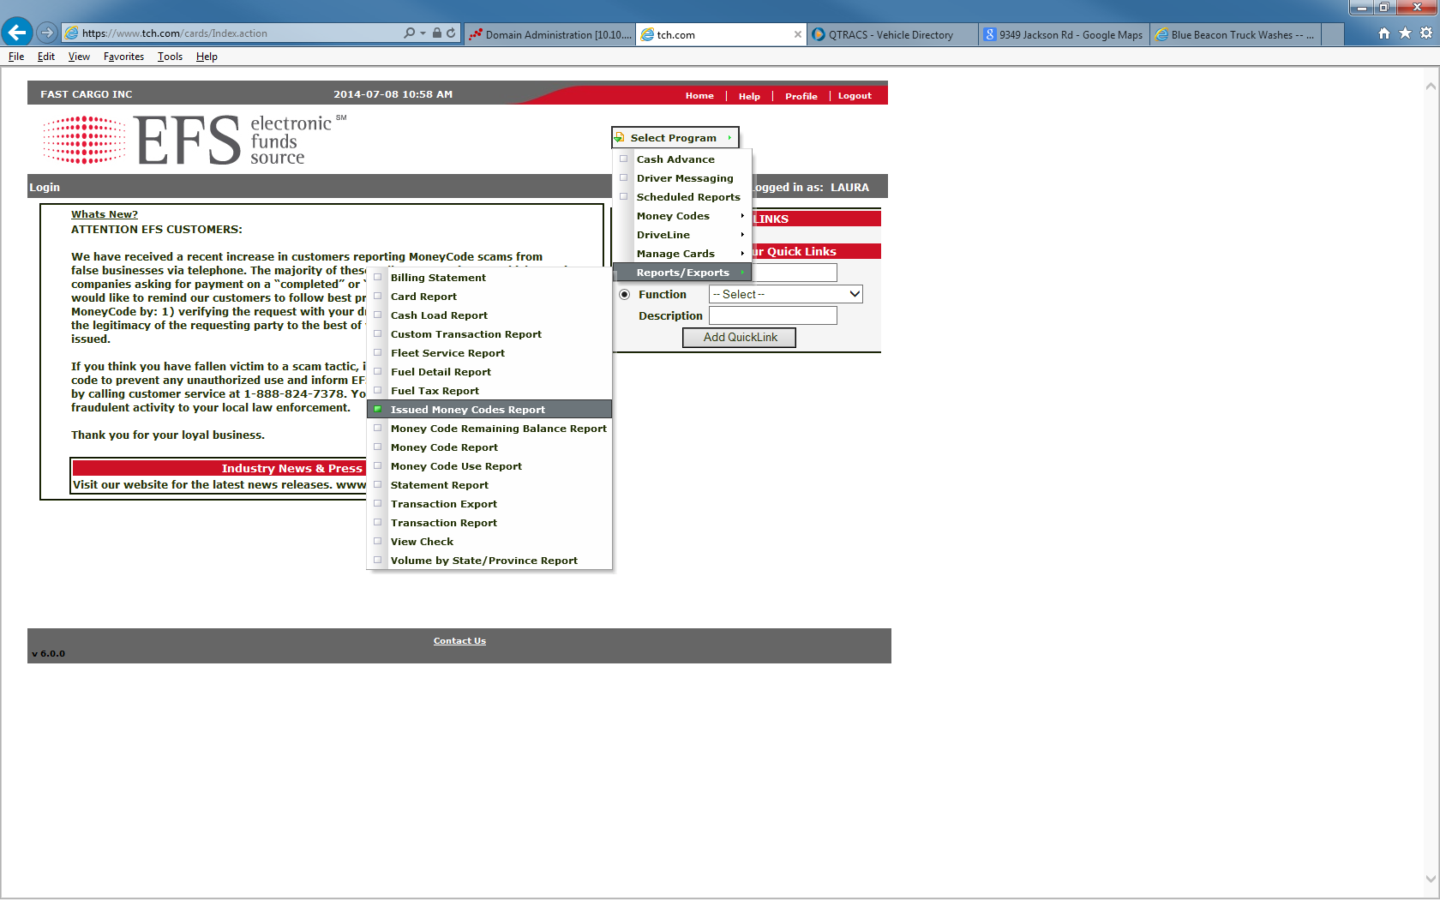
SCREEN: Issued Money Code Report
Parameters are automated set, as example image displayed below, EXCEPT: dates and View Format Type
DATES: Should be the same date of wire transactions
This is NEVER a present date, must be a date in the past.
VIEW FORMAT TYPE: Excel

Click SUBMIT to download the report.

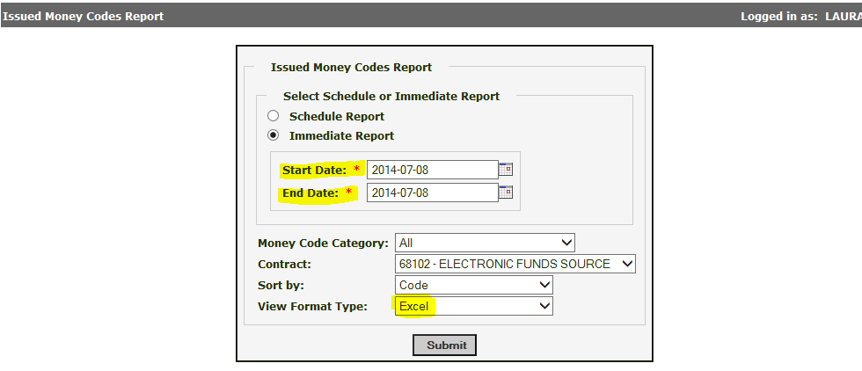
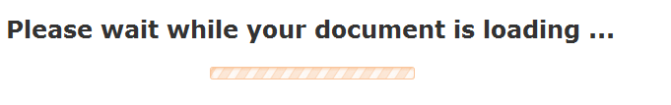

SCREEN: Document Complete | Opening the XLS Issued Money Code Report
Click on ‘Click here to view the document’ to proceed with the downloading.
Click OPEN: This will open the XLS Issued Money Code Report

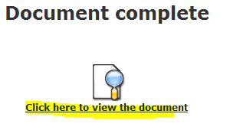

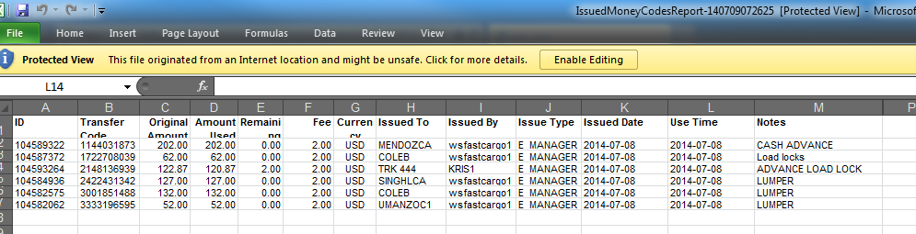

Understanding the Columns and its’ Definition’s
COLUMN A: [ID] is known as the Control Number (Company Reference No.)
COLUMN B: [Transfer Code] is known as the Check Code Number (Driver’s Reference No.)
COLUMN C: [Original Amount] is known as the amount the code was generated for, including the fee.
If this field is empty along with Columns D and E, this indicates that the wire was void out. AND would still need to be entered in DSS, Inc McLeod.
COLUMN D: [Amount Used] displays the amount used VS. column C
COLUMN E: [Remaining Amount] how much money is left of the used amount.
COLUMN H: [Issued To] sould display the payee code or a unit number (Required for when entering money codes genreated via website)
COLUMN I: [Issued By] Denotes the name who created the wire
wsfastcargo1= Created via McLeod System
If this field has a diifrrent title other than ‘wsfastcargo1’ this measn the wire was done through EFS site and thus needs manually entered in DSS, Inc. McLeod.
COLUMN K: [Issued Date] This column must have all the same dates, if not, re-run the report.
COLUMN M: [Notes] this field should have a brief description of what the wire was for.
This field sometimes cuts when there are too many characters within the notes.

Entering EFS Wire Codes into DSS
If you found any codes within Column I denoting an entity name other than wsfastcargo1, it must be manually entered.
Procedure:
Open DSS, Inc. McLeod > Settlement Processing > Wire Funds Processing
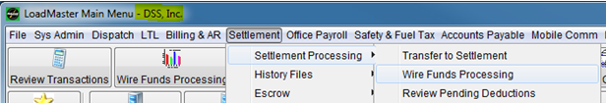
- Wire Funds Transaction Screen: Click Add
- Date: match with the issue date on the spreadsheet
- Driver Code: Enter the driver Code
- Payee Code: Enter the driver’s corresponding payee code
- Order : Enter the the seven digit order number this should be found under the notes description.
- If no order number is described, send an e-mail to the Issuer to associtaed the wire with it.
To: Issuer, Issuers’ Manager; CC: Your manager
- OR: Search drivers or units view history activity and assoicate the order with the possible date match.
- Wire Code: Insert the wire service code that best fits the wire. If unknown, ask your manager.
- Provider Code: Automated
- Control Number= Column A from the spreadsheet
- Check Code Number = Column B from the spreadsheet
- Wire Serivce Charge: The wire fee
- Via McLeod Fee: $2.00
- Via EFS Site Fee: $0.00
- If it is a void check, it is also $0.00
- Check Amount: Match with Column C from the spreadsheet
If it is a VOID check the amount should be 0.00
- Fee to driver: If the wire is to deduct the fee, this field should automatically be filled in, on the account of the WIRE CODE itself, it’s an automated switch.
- BOX Create Deduction: Mark this box in order to create a deduction.
This should box should never be marked it the wire is a void check.
See TABLE CHART below of WIRES that should NOT TO CHARGE certain drivers.

Image example of an EFS genrated wire from 07/08/14 entered into DSS, Inc. McLeod below.
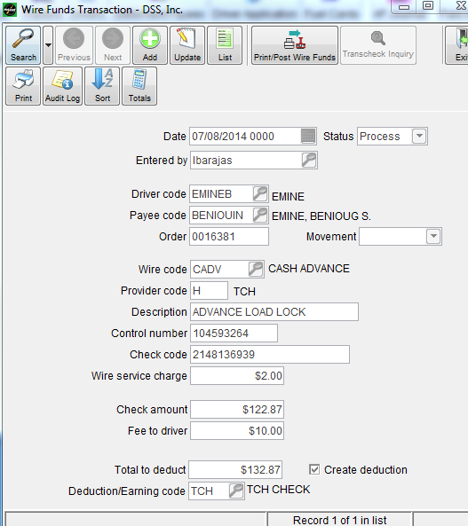
AUDITING: Lumpers /Match Amounts
Audit all the Lumpers and make sure that they are entered into the loads they have been issued against in both DSS and Xpress. If it isn’t attached you will need to enter it on the loads.
Audit the Totals From DSS, Inc. McLeod vs. Totals in Spreadsheet.
Once Matched you can post.
If it does not match, please re-audit.
Final Step: POSTING WIRES
Open DSS, Inc. McLeod > Settlement Processing > Wire Funds Processing

Procedure:
- Click Search
- On the date field and enter only the single date of which wire transactions your posting.
- Click on Print/Post Wire Funds
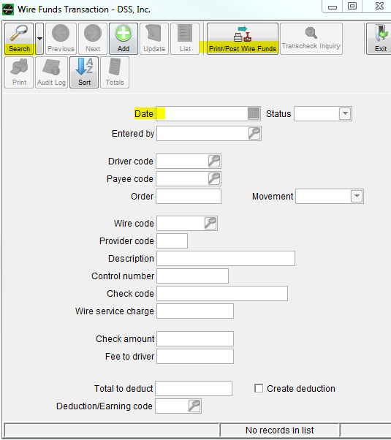

- Next Screen: Print/Post Wire Funds- DSS, Inc.
a.) Cutoff date= single date in the past, never present. Should match with that of the date of the wires.
b.) Unselect the BOX Print edit list
c.) Select the BOX Post transactions
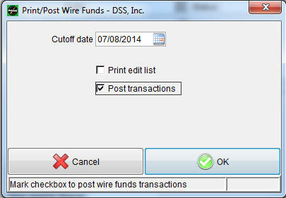
Send out a notification e-mail of wires being posted:
Include only your department of the notification and provide the totals.
TABLE CHART of WIRES that should NOT CHARGE certain drivers
 | Company | Lease Driver | Owner Operator
 |  | applicable on own equipment, otherwise consult
CADV | YES, no fee | YES, include fee | YES, include fee
DUMPER | NO | NO | NO
HOTEL | NO | YES | YES
LUMPER | NO | NO | NO
PERMITS | NO | NO | YES, only if OWN authority
MISC | Consult | Consult | Consult
ORIENT | NO | YES | YES
ORN. ADV | NO | YES | YES
PAYADV | YES, no fee | YES, consult fee | YES, consult fee
TOLLS | NO | Consult | Consult
TRUCK REP. | NO | YES | YES
TRL REP. | NO | Consult | Consult
WASH | NO | YES | YES

